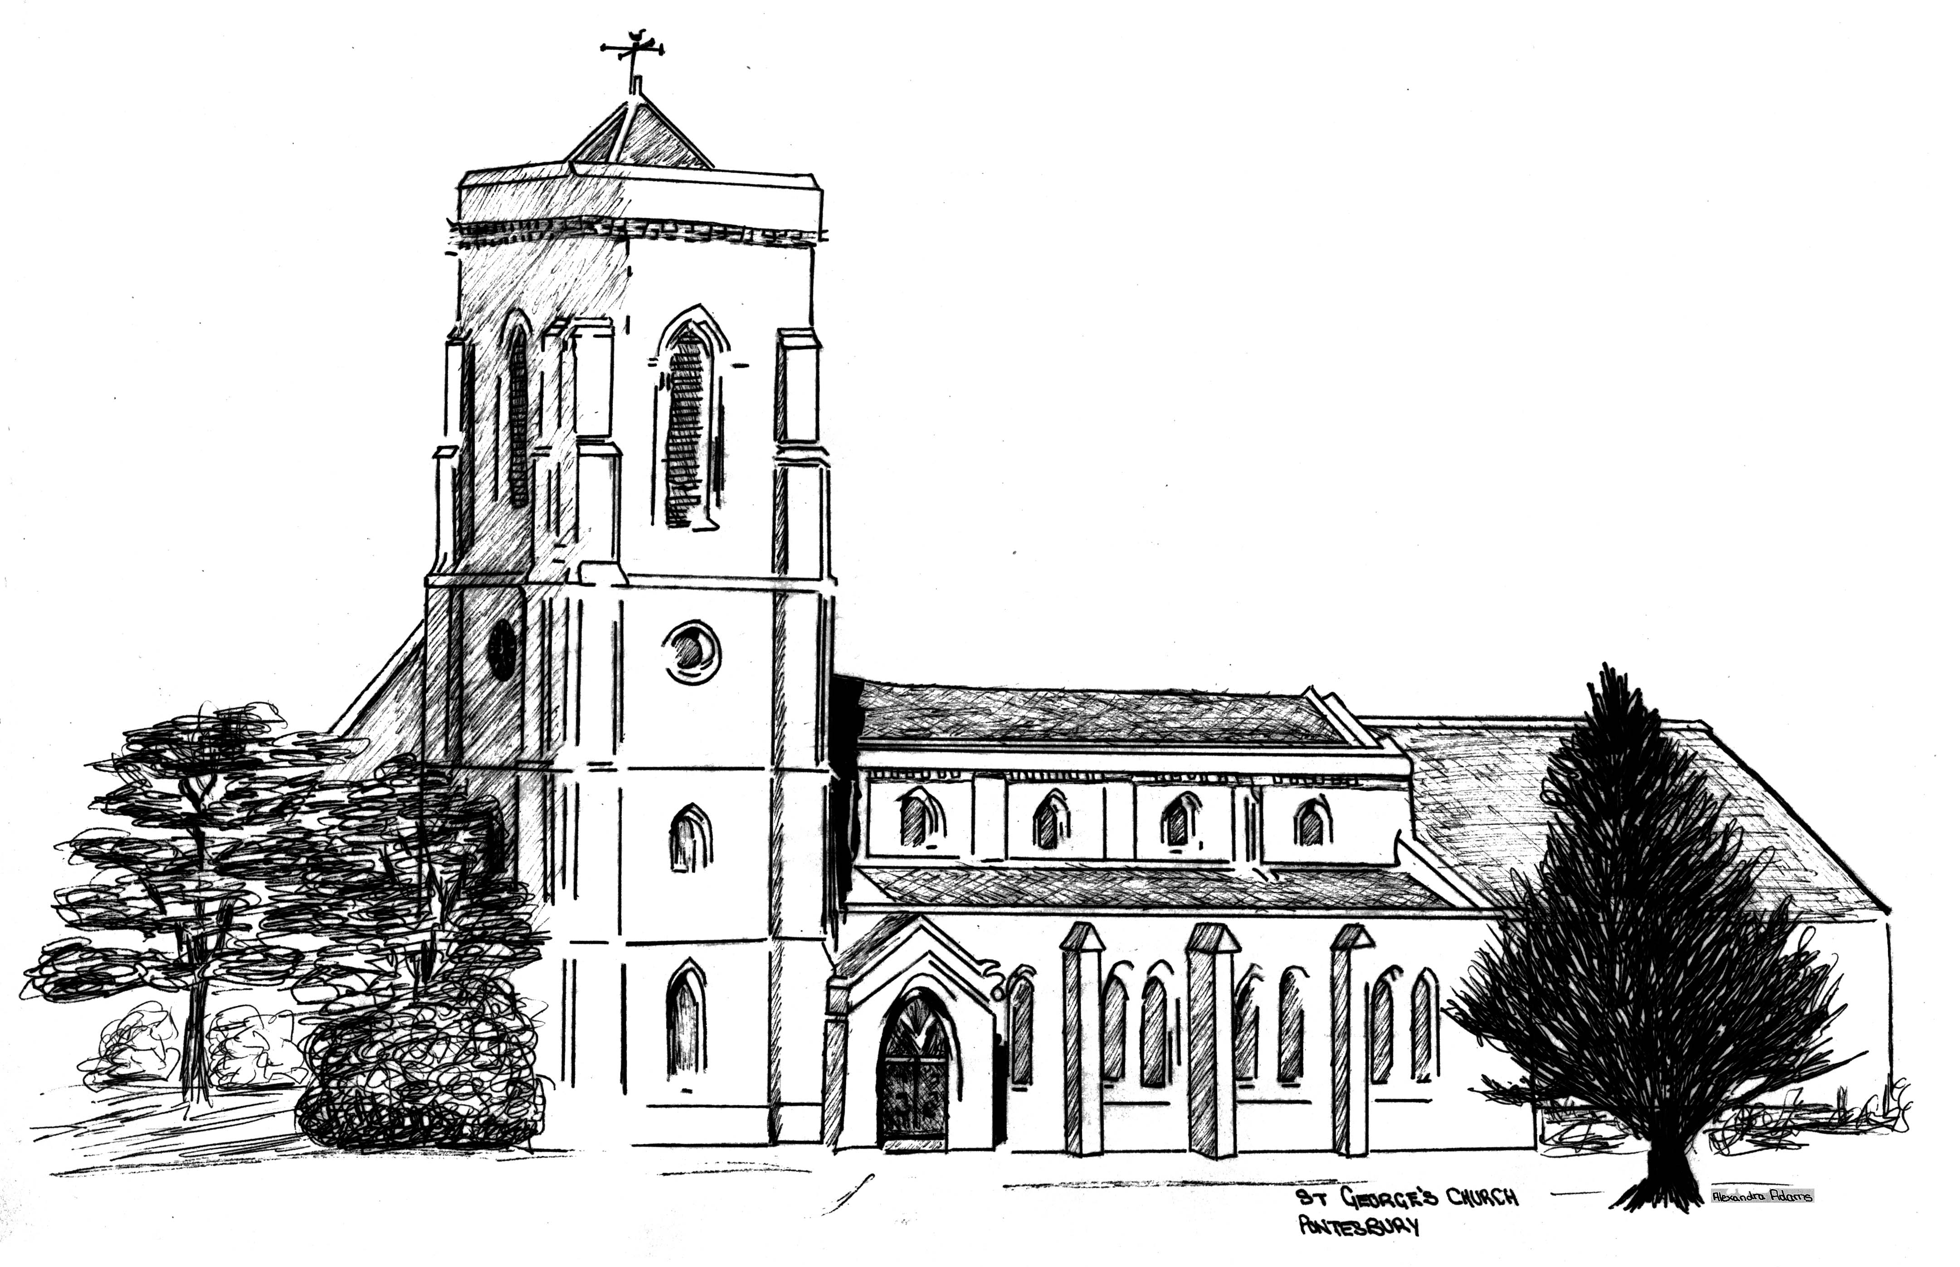
ST GEORGE’S CHURCH
PONTESBURY

APPLICATION FOR BAPTISM

Name(s) of candidate

Date of birth

Home Address

Telephone No

Father’s name

Occupation ………………………………………………….. Signature

Have you been Baptised? .................................. Confirmed?

Mother’s Name

Occupation …………………………………………………… Signature

Have you been Baptised? ……….…….................... Confirmed?

Date and time of Baptism

Approximate numbers attending service

Baptism Preparation

Name and address of Godparents:

1

Baptised? Confirmed?

2

Baptised? Confirmed?

3

Baptised? Confirmed?

4

Baptised? Confirmed?

Permission received (if non-resident)?

Please return the completed form to: The Reverend Greg Smith, The Deanery, Pontesbury SY5 0PS. Telephone: 07902794653. E-mail: rectorpontstip@gmail.com 4 weeks before the baptism is due to take place. Thank you.

BAPTISM NOTES
_________________________________________________________________________

We are pleased you are having a baptism service at St George’s Church. The following notes on Baptism will provide you with some helpful information.

In Baptism, parents thank God for his gift of life, make a decision to begin their child’s journey of faith and ask for the Church’s support.

Baptisms normally take place at 12.15pm on Sundays, but they can also be arranged during the 10.30am Eucharist or All Age Service.

It is usual to have three godparents, two of the same sex as the child and one of the opposite sex, but to have one godfather and one godmother is sufficient. Parents may be godparents to their own children, provided that the child has at least one other godparent.

Church law requires that godparents should be baptised and confirmed but the requirement of confirmation can be relaxed. If you have a query about this, please consult one of the clergy team at St George’s Church.

It is preferable that a child should be baptised at the church the parents normally attend. Parents who do not live within the parish of St George’s or who are not on the Electoral Roll of St George’s are required to obtain the agreement of the priest in whose parish you live for the baptism to take place at St George’s Church.

We have regular Baptism Preparation sessions to which you will be invited. There will be one arranged before 10your baptism date. This is an opportunity to find out more about the service and meet other families. Please bring along your child's godparents too if they are able to come.

A Prayer
Heavenly Father,
thank you for the gift of (child’s name)
and for all the joy she/he brings us.
Be with her/him on her/his Christian journey
so she/he may come to know our Lord Jesus Christ
as Saviour and friend. Amen.

St George’s Pontesbury is a Christian Community providing a loving and spiritual environment in which to embrace, explore and experience faith in order to serve our community.

